MINERVA INTERNATIONAL FREIGHT FORWARDERS ASSOCIATION

12th Annual General Meeting

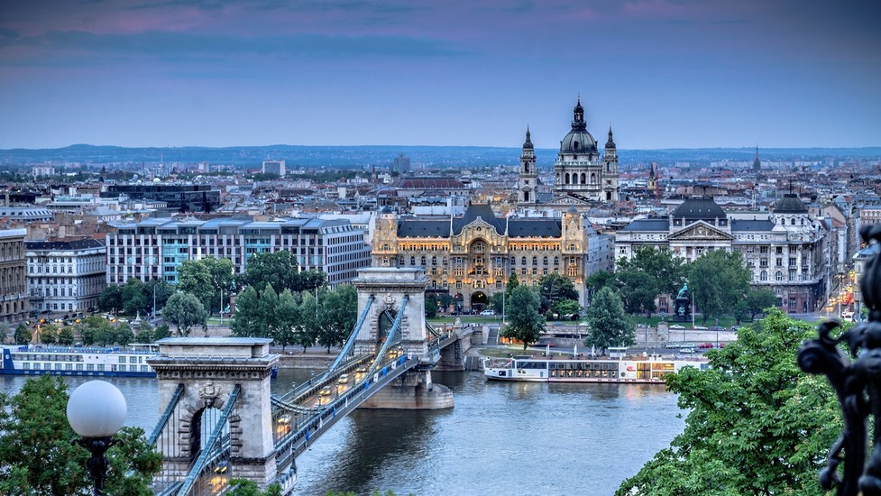

BUDAPEST – HUNGARY

CORINTHIA HOTEL*****

SUNDAY 22ND – WEDNESDAY 25TH
APRIL 2018

REGISTRATION FORM

COMPANY NAME :

NAME PARTICIPANT(S):

ADDRESS:

COUNTRY:

VAT NUMBER:

PERSON IN CHARGE OF MAKING RESERVATION:

Name:

Phone:

Fax:

Email address:

Comments:

HOTEL AND MEETING REGISTRATION

M.I.F.F.A. 12th Annual General Meeting will be held at

CORINTHIA HOTEL***** BUDAPEST – HUNGARY

ALL-IN PACKAGE PRICE

COVERING 3 NIGHTS + 1 ATTENDANCE FEE

Inclusive of :
- ROOM RATES with breakfast I city tax I porterage I internet I spa facilities
- WELCOME RECEPTION on Sunday
- ATTENDANCE FEE on Monday, Tuesday and Wednesday incl. coffee breaks & lunches
- DINNER on Monday
- GROUP ACTIVITY on Tuesday afternoon
- GALA EVENING and Award remittance on Wednesday

- EARLY BIRD RATES valid before November 15th 2017

BEFORE 15/11 AFTER 15/11 2nd ATTENDANT EXTRA NIGHT
Superior Room + Attendance Fee
Single € 1.695 1.895 1.495 190
Double € 1.770 1.970 215
Deluxe Room + Attendance Fee
Single € 1.780 1.980 1.580 220
Double € 1.850 2.050 245
Executive Club + Attend. Fee
Single € 1.920 2.120 1.720 265
Double € 1.990 2.190 290

- 2ND ATTENDANT IN SAME ROOM INCL. ATTENDANCE FEE = € 950

SAME RATES FOR ROOMS 3 NIGHTS PRIOR AND POST EVENT.

ROOM SPACE BEFORE AND AFTER CONFERENCE DATES IS SUBJECT TO AVAILABILITY.

UPGRADE ROOMS (DELUXE ROOM/ EXECUTIVE CLUB) ARE SUBJECT TO AVAILABILITY.

PARTNER / SPOUSE PERSONS PROGRAM

390 EURO PER PERSON FOR 3 NIGHTS

Inclusive of :
- ROOM RATES with breakfast I city tax I internet I spa facilities
- WELCOME RECEPTION on Sunday
- DINNER on Monday
- LUNCH on Tuesday + GROUP ACTIVITY in the afternoon
- GALA EVENING WITH DINNER on Wednesday

_____________________________________________________________________________

ADDITIONAL ACTIVITIES
Additional activities will be proposed locally
and depending on the number of participants

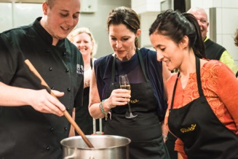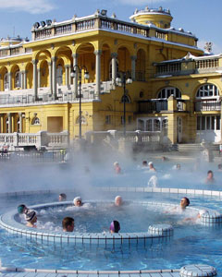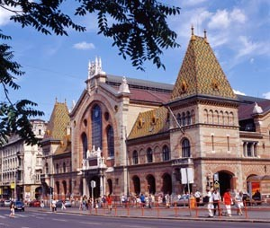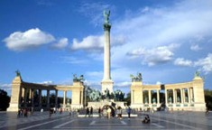

FLIGHT INFO

 | AIRLINE + FLIGHT NUMBER | DATE | TIME
ARRIVAL FLIGHT INFO
DEPARTURE FLIGHT INFO

SPECIAL FOOD REQUEST

A: will need a special meal:
vegetarian
diabetic
other :
B: will need a special meal:
vegetarian
diabetic
other :

VISA & OTHER DOCUMENTS

Please make sure to inform yourself in time of the adequate travel documents needed to enter or travel to Hungary.
We experienced that – depending on the country you are living in – getting a visa may take SEVERAL MONTHS. We therefore highly recommend you to apply for it well in advance.

REGISTRATION CONFIRMATION

NAME(s) | SINGLE/  DOUBLE | Standard room/ deluxe room | ARRIVAL  DATE | DEPARTURE  DATE | MEETING  ATTENDANCE
1.  2. | SGL  DBL | Superior room  Deluxe room  Executive Club room |  |  | 1.  2.
1.  2. | SGL  DBL | Superior room  Deluxe room  Executive Club room |  |  | 1.  2.

ALL IN PACKAGES (incl. room + attend. fee) | 1st attendant | 2nd attendant | extra night | total
SINGLE SUPERIOR PACKAGE IN EURO  Early bird 1.695 / 1.895 | X | 1495 X | 190 X | = €
DOUBLE SUPERIOR PACKAGE IN EURO  Early bird 1.770 / 1.970 | X |  | 215 X | = €
SINGLE DELUXE PACKAGE IN EURO  Early bird 1.780 / 1.980 | X | 1580 X | 220 X | = €
DOUBLE DELUXE PACKAGE IN EURO  Early bird 1.850 / 2.050 | X |  | 245 X | = €
SINGLE EXECUTIVE PACKAGE IN EURO  Early bird 1.920 / 2.120 | X | 1720 X | 265 X | = €
DOUBLE EXECUTIVE PACKAGE IN EURO  Early bird 1.990 / 2.190 | X |  | 290 X | = €

2ND ATTENDANT IN SAME ROOM (incl. attend. Fee)
1 PACKAGE = 950 € |  | X persons |  | = €

PARTNER / SPOUSE PERSONS PROGRAM
1 PACKAGE = 390,00€ |  | X persons |  | = €

TOTAL = €

DATE | SIGNATURE

IMPORTANT – IMPORTANT – IMPORTANT

REGISTRATIONS MUST BE MADE BEFORE THE 15TH OF NOVEMBER 2017.
After this date, reservations are subject to space availability and higher prices.

THE REGISTRATION FORM MUST BE ACCOMPANIED
BY THE PAYMENT OF THE TOTAL SUM by BANKDRAFT
OR BY CREDIT CARD TO UNIGLOBE B&L TRAVEL.

PLEASE MAKE SURE THAT THE TOTAL AMOUNT IS PAID BEFORE
the 15TH OF NOVEMBER 2017.
PARTICIPANTS WHOSE PAYMENT IS NOT RECEIVED IN FULL WILL BE REFUSED.

BANK INFORMATION UNIGLOBE B&L TRAVEL :

BANK : ING BANK
ADDRESS : KAPELLESTRAAT 36 - 2630 AARTSELAAR - BELGIUM
IBAN NUMBER: BE27 3631 3094 3673
BIC (SWIFT CODE): BBRUBEBB

Please note that ALL BANK COSTS are for YOUR ACCOUNT
and that payments need to be done in EURO

Kindly indicate the following instructions on all payments:

MIFFA - 70721 and YOUR COMPANY NAME.

CREDIT CARD INFO

If you wish to pay with credit card, please provide all credit card details here below.

CREDIT CARD TYPE :

CREDIT CARD NUMBER :

EXPIRY DATE: /

NAME ON CARD:

CVV (SECURITY CODE ON THE BACK):

PLEASE CHARGE MY CREDIT CARD FOR THE TOTAL AMOUNT – MIFFA CONFERENCE 2018 EXPENSES.

RETURN PAGES TO

Please make reservations with UNIGLOBE B&L TRAVEL, only by USING this registration form.

UNIGLOBE B&L TRAVEL
ATTN MIRYAM SCHEFFERS

Kapellestraat 58
B-2630 Aartselaar
Belgium

Phone: +32 3 443 72 40

Email: mscheffers@uniglobebltravel.be

